
The poll was conducted April 4 through April 16, 2018.
368 U-reporters under the age of 21 years old participated in it (from Donetsk and Luhansk oblast).

Poll «Mine Safety»

The main purpose of the poll is to provide the results for improvement the information campaign against mines and explosives and for planning interventions in the field of mine security next year.
- Have you seen the UNICEF information campaign about mines safety this year?

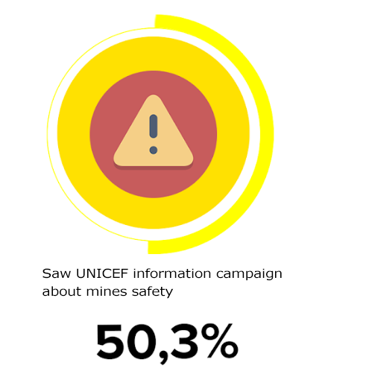
- More than half of U-reporters under the age of 21 from Donetsk and Luhansk oblast saw the information campaign about mines safety - 50.3% (Figure 1), have not seen - 39.9%, it is difficult to answer - 9.8%.
- 49.8% U-reporters from the Donetsk oblast saw advertising, 53.3% ones from the Lugansk oblast.
- U-reporters at the age of 14-15 years and 16 years more often saw the UNICEF information campaign about mines safety (60% and 62.2% in accordance); 13 years and younger - 42.9%, 17-18 years - 49.5%, 19-20 years - 32.9%.

Fig.1. Distribution of answers to the question: "Have you seen the UNICEF information campaign about mines safety this year?”, %, N = 368

- What measures would be the most effective in informing pupils about mines safety?
- Most U-reporters said that the most effective measures for informing pupils about mines safety would be the stories of children affected by the explosion of mines - 37.3%, teachers’ training sessions - 32.3%, games-performances - 26.4%, video lessons - 22.4%, online games - 17.8%, peer education trainings - 16.8%, others - 3% (Figure 2).
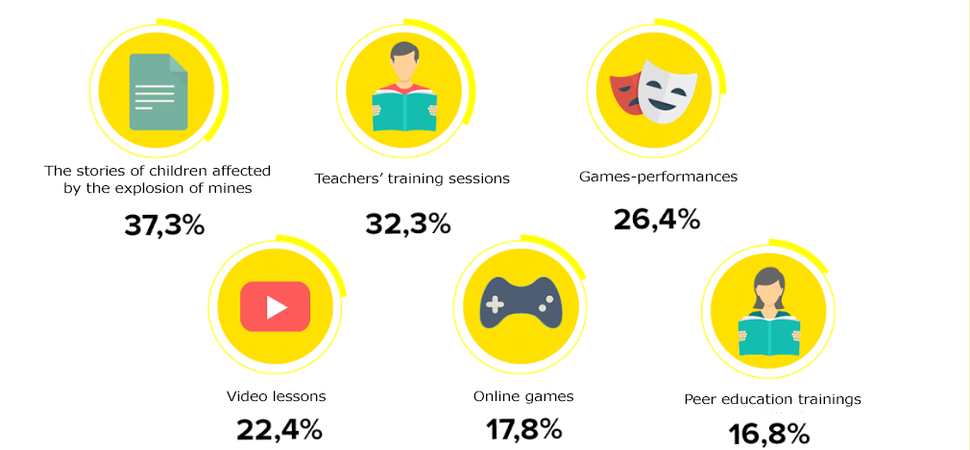
Fig.2. Distribution of answers to the question: "What measures would be the most effective in informing pupils about mines safety?", N = 303
- U-reporters from the Donetsk oblast more often chose the answer - the stories of the children affected by the explosion of mines - 39,1%, training trainings from teachers (33,1%) and games-performances (27.4%). U-reporters from the Luhansk oblast more often referred to trainings from the teachers (27.0%), the stories of children affected by the explosion of mines (24.3%), video tutorials (24.3%) and online games (24.3%) (Figure 3).
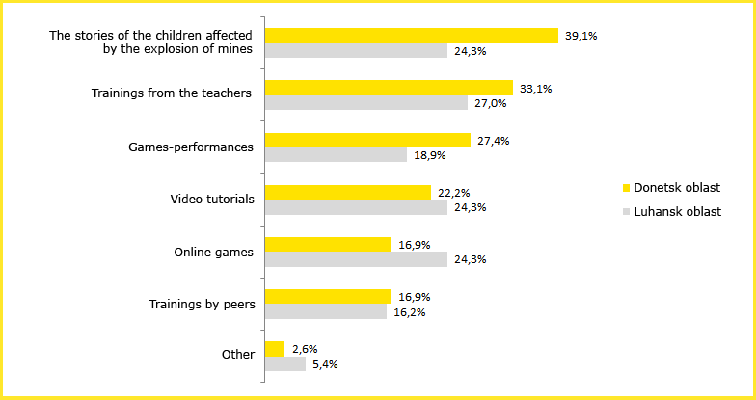
Fig.3. Distribution of answers to the question: "What measures would be the most effective in informing pupils about mines safety?”, by oblast, N = 303

- Did you have anything from the list below on the subject of mines safety at your school?

- Almost half of U-reporters responded that in their educational institution there were handouts on the subject of mines safety - 49.8%, lessons, lectures on the mentioned topics - 43.4%, trainings - 12.8%, none - 22.1 % (Fig. 4).
- Among the Luhansk and Donetsk oblasts, respectively: handouts (64.7% vs. 47.8%), lessons / lectures in educational institutions (35.3% vs 44.5%), trainings (14.7% vs. 12.6%).

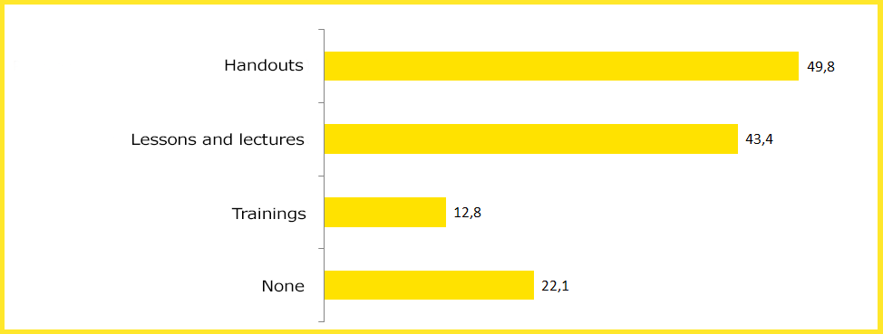
Fig.4. Distribution of answers to the question: "Did you have anything from the list below on the subject of mines safety at your school?", %, N = 281

Summary: 50.3% of U-reporters saw an information campaign about mines safety, 37.3% believe that the most effective mine safety measures would be to inform the pupils about the stories of children affected by mines, 32.3% - teachers’ lessons; 49, 8% saw handouts on the subject of mines safety in their educational institution.

