
The poll was conducted December 26, 2018 through January 3, 2019.
8926 U-reporters at the age of 18 – 25 years old participated in it

Poll "A Sense of Safety. Mariupol»

The main purpose of the poll is to analyze the sense of safety among young people in the Mariupol for Mariupol City Council information campaign regarding public safety measures (particularly among pupils and students); to use the data in the activities of public and eco-activists of Mariupol.
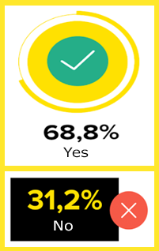
- Do you feel safe in Mariupol?

- The vast majority of U-reporters from Mariupol (68.8%) said that they feel safe in their city; 31.2% do not feel safe there (fig. 1).
- According to age groups, the percentage of those who do not feel safe in Mariupol was distributed as follows: 14-17 years - 31.7%, 18-19 years - 36.4%, 20-24 years - 27.7%, 25 -34 years - 26.8%.
• Women more often than men did not feel safe - 34.9% vs 23.5%.

Fig.1. Answers to the question: "Do you feel safe in Mariupol?", N = 337

- What affects (may affect) your feelings of concern and insecurity?
- Among those U-reporters who do not feel safe in Mariupol (N = 97), feeling of concern and insecurity was caused by the ecological situation in the city - 60.8%, proximity to fighting - 52.6%, martial law - 38.1%, fake news - 21.6%, other (crime, criminality, aggression of people) - 13.4% (Figure 2).
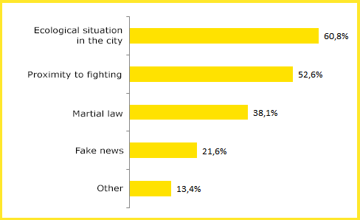
Fig.2. Distribution of answers to the question: «What affects (may affect) your feelings of concern and insecurity?”, N=97

- Those young people who now feel safe in Mariupol (N = 215) answered the question "What may affect your feelings of concern and insecurity?" as follow: the proximity to fighting (50.2%), ecological situation in the city (40%), martial law (23.3%), fake news (21.4%), and other (5.1%).
- Women, more often than men said that their feelings of concern may be affected by proximity to fighting (53.6% vs 45.9%) and martial law (25.6% vs. 16.2%).

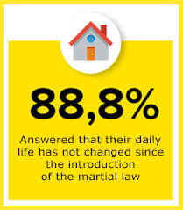
- Did you feel some changes in your daily life after the introduction of the martial law?

- According to 88.8% of U-reporters, their daily life has not changed since the introduction of the martial law - 92.6% among women and 82.8% among men (Fig. 3); 11.2% answered that their daily life has changed.

- What kind of changes did you feel?
- Among those respondents who indicated that their life has changed (N = 23), the following significant changes were named: deterioration of the nervous condition, continuous inflammation of the situation; economic problems (rising prices, etc.); changes in work schedule; household and social changes; restrictions on movement and increased control and patrolling of the streets, more frequent verification of documents; traffic problems, block posts.
Fig.3. Number of negative answers to the question: "Did you have some changes in your daily life after the introduction of the martial law?”, N = 303

- What would you advice the local authorities to enhance the sense of security in Mariupol?
- In order to enhance safety in Mariupol, U-reporters would advise following to the local authorities: to increase control over the order and security of the city and compliance with laws, to control the quality of law enforcement bodies’ work and increase patrolling of the streets (30.3%); to improve the ecological situation in the city, to establish sewage treatment manufactories, filters at factories, control over observance of environmental norms (15.8%); to provide people with true information and communicate with the public (12.5%); to increase the level of street lighting (11.2%); to stop the war (4.6%); to increase social standards, living conditions, payments (3.9%); to solve problems at the state level (3,9); to conduct more activities for youth and make the holiday spirit (2.6%); to conduct training on self-defense and the proper handling of ammunition (2.6%) (Figure 4).
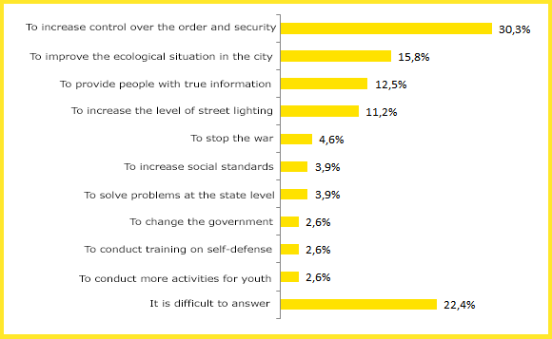
Fig.4. Distribution of answers to the question: «What would you advice the local authorities to enhance the sense of security in Mariupol?”, N=152
Summary: 68.8% of U-reporters from Mariupol feel safe in their city. Among those U-reporters who do not feel safe in Mariupol (N = 97), feeling of insecurity was caused by the environmental situation in the city (60.8%), the proximity to fighting (52.6%), martial low (38.1%), fake news (21.6%). Since the introduction of martial low, 88.8% of U-reporters haven't felt changes in their daily lives. U-reporters would advise the local authorities to increase control over order and security (30.3%) and to improve the environmental situation in the city (15.8%) in order to enhance the sense of safety in Mariupol.

